TASK on S3 – 03/09/2026

- Create an S3 bucket and upload some objects to S3.

Objective
To create an Amazon S3 bucket and upload objects (files) into it.

Components Used

Amazon S3
Definition:
Amazon S3 (Simple Storage Service) is an AWS object storage service used to store and retrieve data.

S3 Bucket
Definition:
A bucket is a container in Amazon S3 used to store objects.

S3 Object
Definition:
An object is the actual data or file stored inside an S3 bucket.
Examples:
file.txt
image.jpg
document.pdf

AWS Region
Definition:
An AWS Region is a geographical location where AWS resources are deployed.
Used Region:
ap-southeast-1 (Singapore)

Implementation Steps
- Logged in to the AWS Management Console.
- Opened the Amazon S3 service.
- Clicked Create bucket.
- Entered a globally unique bucket name.
- Selected the Region:
Asia Pacific (Singapore) — ap-southeast-1
- Configured the required bucket settings.
- Created the S3 bucket.
- Opened the created bucket.
- Clicked Upload.
- Selected files from the local system.
- Uploaded the files into the bucket.

Architecture
AWS Cloud
│
Amazon S3
│
▼
S3 Bucket
│
┌─────────┼─────────┐
│ │ │
▼ ▼ ▼
file1.txt file2.txt image.jpg
Object Object Object

Result
Successfully:
- Created an Amazon S3 bucket.
- Created the bucket in ap-southeast-1 (Singapore).
- Uploaded multiple objects/files into the bucket.

Final Result
The S3 bucket was successfully created, and objects were successfully uploaded and stored in Amazon S3.

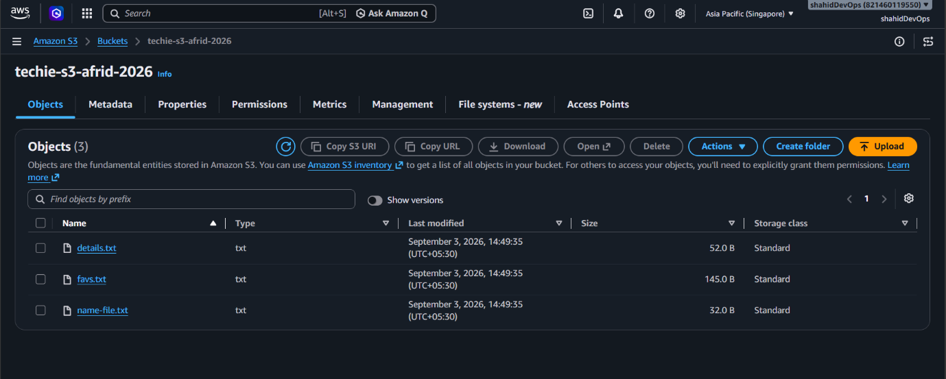

- Deploy a static website in the S3 bucket.

Objective
- To host and deploy a static website using Amazon S3.

Components Used
- Amazon S3: An AWS object storage service used to store and retrieve data.
- S3 Bucket: A container used to store website files.
- Static Website Hosting: Allows an S3 bucket to serve static website content through a website endpoint.
- index.html: The main or default webpage.
- error.html: A custom error page displayed when a requested page is not found.
- Bucket Policy: A JSON-based policy attached to the bucket to control access.

Architecture
User Browser
│
│ Website Endpoint
▼
Amazon S3
│
▼
S3 Bucket
├── index.html
└── error.html

Implementation Steps
- Created two HTML files:
  - index.html
  - error.html
- Added website content to the HTML files.
- Uploaded both files to the S3 bucket.
- Enabled Static Website Hosting:
S3 → Bucket → Properties → Static website hosting
- Configured:
Hosting type: Host a static website
Index document: index.html
Error document: error.html
- Block Public Access was disabled while creating the bucket.
- Added a bucket policy to allow public read access:
{
"Version": "2012-10-17",
"Statement": [
{
"Sid": "PublicReadGetObject",
"Effect": "Allow",
"Principal": "*",
"Action": "s3:GetObject",
"Resource": "arn:aws:s3:::techie-s3-qafrid-2026/*"
}
]
}
- Accessed the website using the S3 Bucket Website Endpoint.
Example:
http://techie-s3-qafrid-2026.s3-website-ap-southeast-1.amazonaws.com
- .

Result
- Successfully deployed a static website using Amazon S3.
- The website files were publicly accessible.
- The website was successfully accessed through the S3 Website Endpoint.

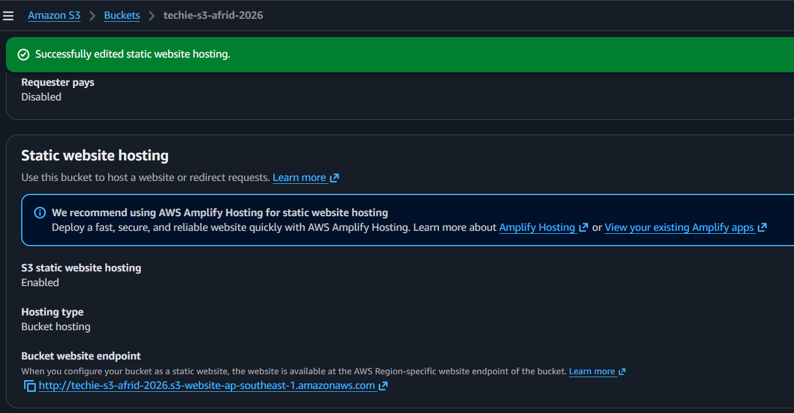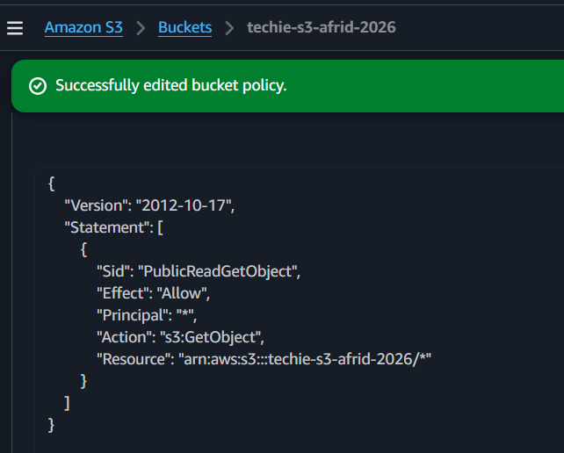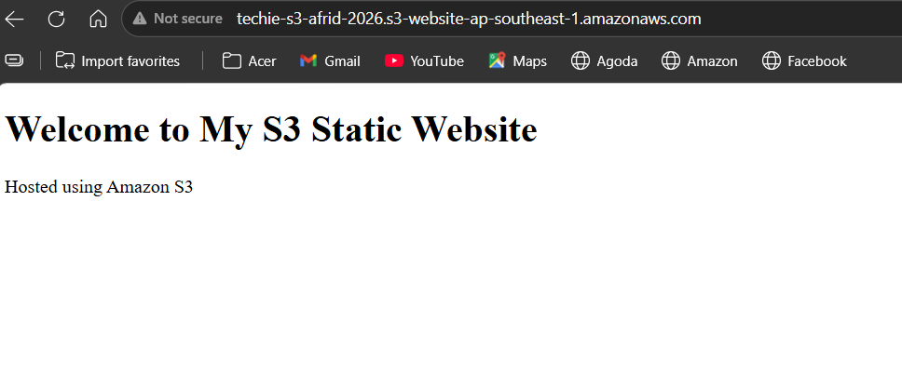
If index.html deleted :
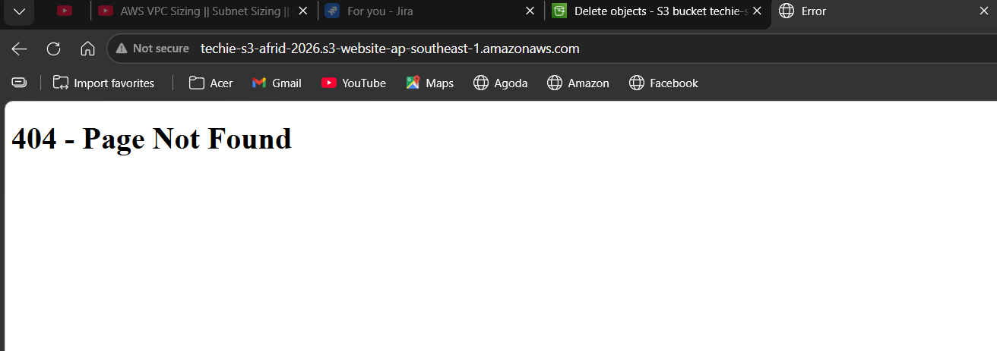

- Enable cross-region replication on S3 buckets.

Objective
- To automatically replicate objects from an S3 bucket in one AWS Region to another S3 bucket in a different AWS Region.

Components Used
- Amazon S3: AWS object storage service used to store and manage objects.
- Source Bucket: The bucket where the original objects are uploaded.
- techie-s3-afrid-2026
Region: ap-southeast-1 (Singapore)
- Destination Bucket: The bucket where replicated copies of objects are stored.
- afrid-destination-crr-2026
Region: ap-south-1 (Mumbai)
- S3 Versioning: Maintains different versions of objects. Versioning must be enabled on both source and destination buckets for CRR.
- Replication Rule: Defines which objects should be replicated and where they should be replicated.
- IAM Role: Provides Amazon S3 with the required permissions to read objects from the source bucket and replicate them to the destination bucket.

Architecture
AWS Region: Singapore
ap-southeast-1

techie-s3-afrid-2026
│
│
│ Cross-Region Replication
│
▼
IAM Replication Role
│
▼

AWS Region: Mumbai
ap-south-1

afrid-destination-crr-2026
A clearer data flow:
New Object
│
▼
Source Bucket (Singapore)
│
│ CRR
▼
Destination Bucket (Mumbai)

Implementation Steps
- Created the source bucket:
- techie-s3-afrid-2026
Region: ap-southeast-1 (Singapore)
- Created the destination bucket:
- afrid-destination-crr-2026
Region: ap-south-1 (Mumbai)
- Enabled Bucket Versioning on both buckets while creating them.
- Opened the source bucket and navigated to:
Management → Replication rules → Create replication rule
- Created a replication rule named:
cross-region-replication
- Configured the rule to apply to all objects in the source bucket.
- Selected the destination bucket:
afrid-destination-crr-2026
- Left the following options disabled because they were not required for this basic task:
  - Replicate SSE-KMS encrypted objects
  - Change destination storage class
  - Replication Time Control (RTC)
  - Replication metrics
  - Delete marker replication
  - Replica modification sync
- Selected:
No, do not replicate existing objects
- An IAM replication role was created automatically:
s3crr_role_for_techie-s3-afrid-2026
- AWS attached the required permissions policy to the IAM role.
- Created the replication rule successfully.

Testing
- Created a new object after the replication rule was enabled:
crr-test.txt
- Uploaded it to the source bucket.
- Amazon S3 automatically replicated the object to the destination bucket.

Important Points
- CRR works between S3 buckets in different AWS Regions.
- Versioning must be enabled on both buckets.
- An IAM role is required to allow S3 to perform replication.
- Objects uploaded after the replication rule is enabled are automatically replicated.
- Existing objects are not replicated automatically unless existing object replication/S3 Batch Replication is configured.
- CRR is useful for disaster recovery, compliance, and geographically distributed data.

Result
- Successfully configured S3 Cross-Region Replication.
- Objects uploaded to the source bucket were automatically replicated to the destination bucket in another AWS Region.

Final Data Flow
crr-test.txt
│
▼
techie-s3-afrid-2026
Singapore (ap-southeast-1)
│
│ CRR + IAM Role
▼
afrid-destination-crr-2026
Mumbai (ap-south-1)

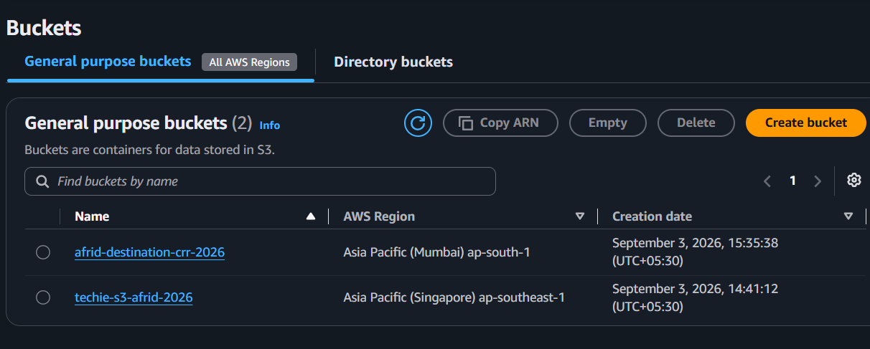

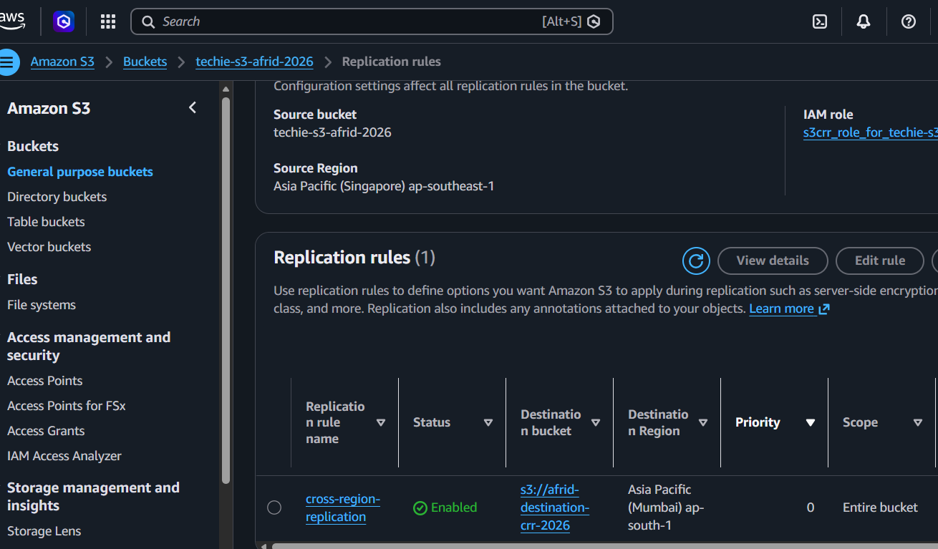

- Configure a bucket policy so only the Admin user can see the objects of the S3 bucket.

Objective
- To configure an S3 bucket policy that allows the Admin IAM user to view and access objects in an S3 bucket.

Components Used
- Amazon S3: AWS object storage service used to store objects.
- S3 Bucket: A container used to store objects.
afrid-admin-only-s3-2026
- IAM User: An AWS identity used to access AWS resources.
User: Admin
- IAM User ARN: A unique identifier for the IAM user.
arn:aws:iam::821460119550:user/Admin
- Bucket Policy: A JSON-based resource policy attached directly to an S3 bucket to control access.
- S3 Objects: Files stored inside the S3 bucket.
admin-test.txt

Architecture
Admin IAM User
│
│ Bucket Policy
│
├── s3:ListBucket
└── s3:GetObject
│
▼
S3 Bucket
afrid-admin-only-s3-2026
│
▼
admin-test.txt

Implementation Steps
- Opened the IAM service.
- Created an IAM user:
Admin
- Attached the AdministratorAccess permission to the Admin user for this lab.
- Created an S3 bucket:
afrid-admin-only-s3-2026
- Uploaded a test object:
admin-test.txt
- Opened:
S3 → afrid-admin-only-s3-2026 → Permissions → Bucket Policy
- Added the following bucket policy:
{
"Version": "2012-10-17",
"Statement": [
{
"Sid": "AllowAdminUserToListBucket",
"Effect": "Allow",
"Principal": {
"AWS": "arn:aws:iam::821460119550:user/Admin"
},
"Action": "s3:ListBucket",
"Resource": "arn:aws:s3:::afrid-admin-only-s3-2026"
},
{
"Sid": "AllowAdminUserToAccessObjects",
"Effect": "Allow",
"Principal": {
"AWS": "arn:aws:iam::821460119550:user/Admin"
},
"Action": "s3:GetObject",
"Resource": "arn:aws:s3:::afrid-admin-only-s3-2026/*"
}
]
}

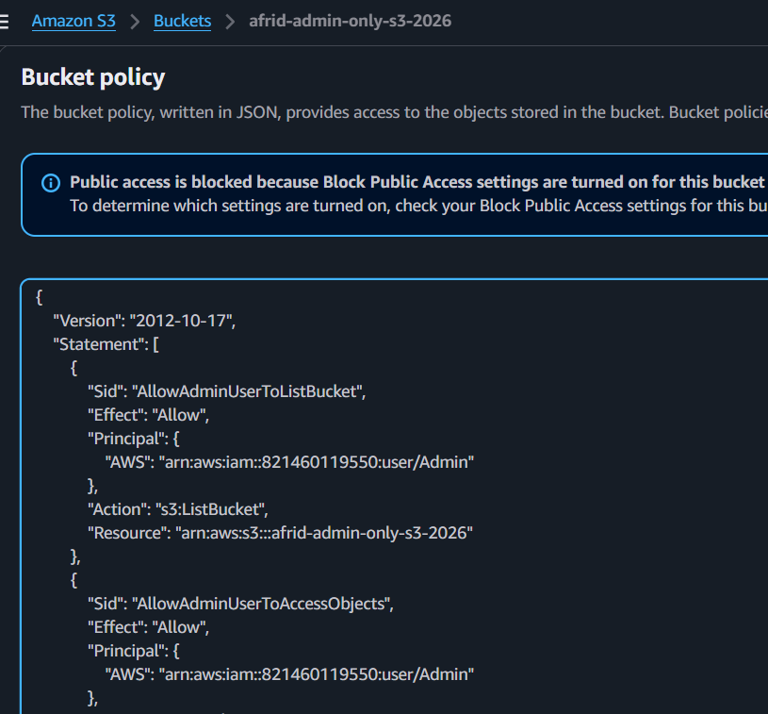

- Enabled Console access for the Admin IAM user.
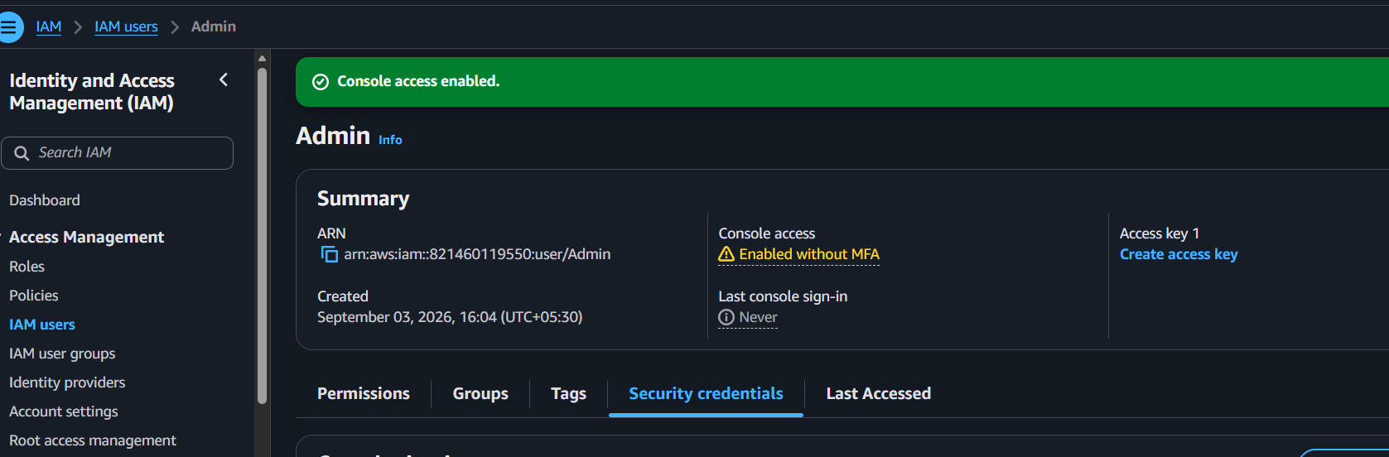
- Signed in as the Admin IAM user using an Incognito/InPrivate browser window.
- Verified access to:
afrid-admin-only-s3-2026

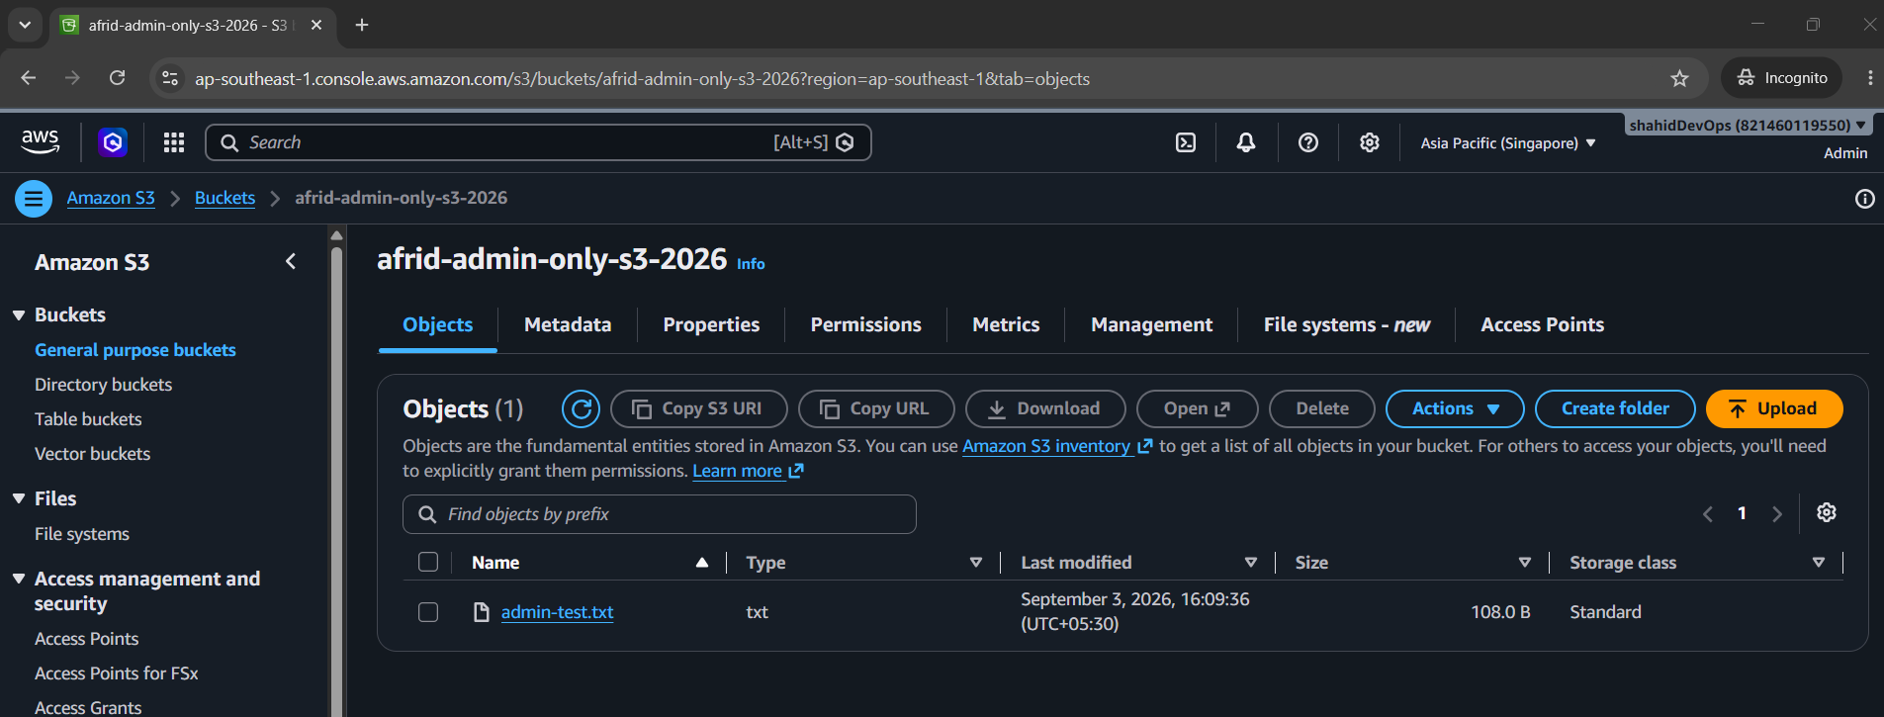
- Successfully viewed:
admin-test.txt

Policy Explanation

Principal
Specifies who receives permission.
Admin IAM User

s3:ListBucket
Allows the user to:
View/List objects inside the bucket

s3:GetObject
Allows the user to:
Read/Open/Download objects

Bucket ARN
arn:aws:s3:::afrid-admin-only-s3-2026
Used for bucket-level permissions such as:
s3:ListBucket

Object ARN
arn:aws:s3:::afrid-admin-only-s3-2026/*
Used for object-level permissions such as:
s3:GetObject

Result
- Successfully created an Admin IAM user.
- Configured an S3 bucket policy.
- Allowed the Admin user to list the bucket and access objects.
- Verified that the Admin user could view admin-test.txt.

Important Note
- The implemented policy allows the Admin user access.
- A strictly exclusive “only Admin and no other identity” configuration would require additional explicit deny logic.
- This was not implemented in this task and can be explored separately.

- Set up lifecycle policies to automatically transition or delete objects based on specific criteria.

Objective
- To automatically transition or delete S3 objects based on specific criteria such as object age.

Components Used
- Amazon S3: AWS object storage service used to store objects.
- S3 Bucket: A container used to store objects.
afrid-lifecycle-2026
- S3 Object: A file stored inside the bucket.
lifecycle-test.txt
- Lifecycle Rule: A set of rules that automatically manages objects based on defined conditions.
- Storage Class: Defines how objects are stored and accessed.
- Transition Action: Automatically moves an object from one storage class to another.
- Expiration Action: Automatically deletes an object after a specified period.

Architecture
lifecycle-test.txt
│
▼
Day 0
S3 Standard
│
│ After 30 days
▼
S3 Standard-IA
│
│ After 90 days
▼
Object Deleted

Implementation Steps
- Created an S3 bucket:
afrid-lifecycle-2026
- Used the default bucket settings.
- Kept Block Public Access enabled.
- Did not enable Bucket Versioning.
- Uploaded a test object:
lifecycle-test.txt
- Navigated to:
S3 → afrid-lifecycle-2026 → Management → Lifecycle rules
- Clicked Create lifecycle rule.
- Created a lifecycle rule named:
transition-and-delete-rule
- Applied the rule to:
All objects in the bucket
- Configured a transition action:
After 30 days → Standard-IA
- Configured an expiration action:
After 90 days → Delete object
- Successfully created the lifecycle rule.

Lifecycle Flow
Object Created
│
▼
S3 Standard
│
│ 30 Days
▼
S3 Standard-IA
│
│ 90 Days
▼
Object Expired/Deleted

Important Points
- Lifecycle rules help automate S3 object management.
- They can reduce storage costs by moving old objects to cheaper storage classes.
- Lifecycle rules can automatically delete objects that are no longer required.
- Lifecycle actions are based on conditions such as object age.
- Lifecycle actions are asynchronous and may not happen immediately at the exact configured time.

Result
- Successfully configured an S3 Lifecycle Policy.
- Objects will automatically transition to Standard-IA after 30 days.
- Objects will automatically expire and be deleted after 90 days.

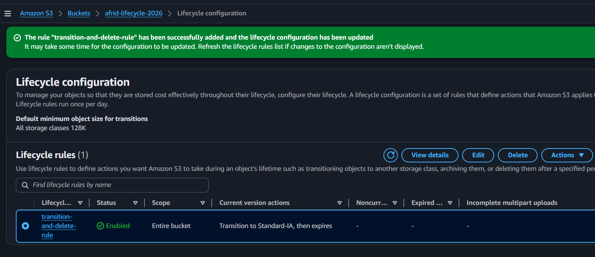
- Push some objects to S3 using the AWS CLI.

Objective
- To upload objects from a local system to an Amazon S3 bucket using the AWS Command Line Interface (AWS CLI).

Components Used
- AWS CLI: A command-line tool used to interact with AWS services.
- IAM User: An AWS identity used to authenticate and authorize AWS CLI requests.
Admin
- IAM Access Keys: Credentials used by the AWS CLI to authenticate the IAM user.
- Access Key ID
Secret Access Key
- AWS CLI Profile: A named configuration containing AWS credentials and settings.
admin-s3
- Amazon S3: AWS object storage service.
- S3 Bucket: The destination where objects are uploaded.
afrid-lifecycle-2026
- S3 Object: A file uploaded and stored inside an S3 bucket.

Architecture
Local Computer
│
│ AWS CLI
▼
IAM User Credentials
│
│ Authentication
▼
Amazon S3
│
▼
afrid-lifecycle-2026
│
├── cli-test.txt
└── 310 rr bwm.jpg

Implementation Steps
- Checked the available AWS CLI profiles:
aws configure list-profiles
- Created an IAM user named:
Admin
- Created an Access Key for the Admin IAM user.
- Configured a new AWS CLI profile:
aws configure --profile admin-s3
- Configured the AWS Region:
ap-southeast-1
- Verified the IAM identity:
aws sts get-caller-identity --profile admin-s3

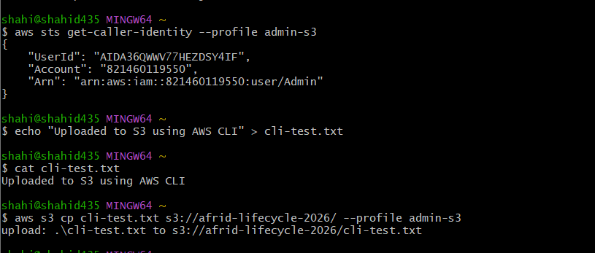

- Created a local text file:
echo "Uploaded to S3 using AWS CLI" > cli-test.txt
- Uploaded the text file to the S3 bucket:
aws s3 cp cli-test.txt s3://afrid-lifecycle-2026/ --profile admin-s3

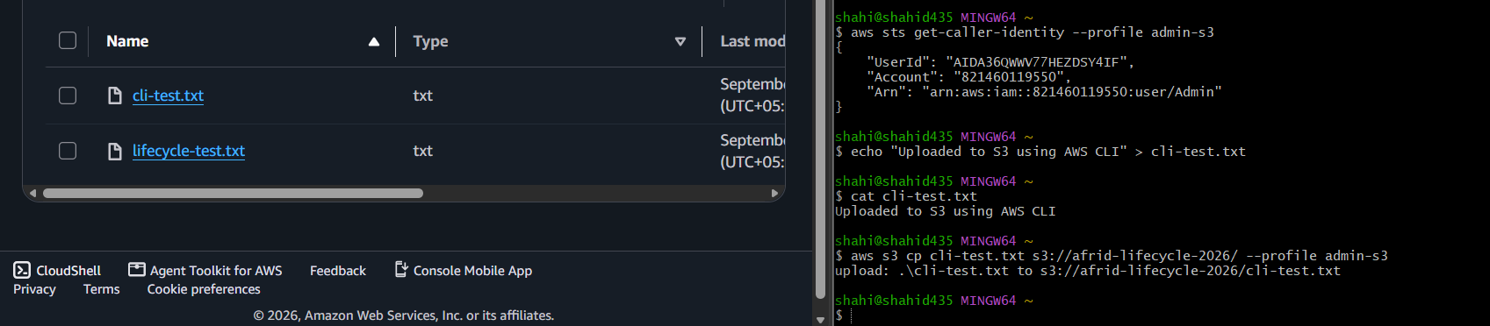

- Uploaded an image file using AWS CLI:
aws s3 cp "310 rr bwm.jpg" s3://afrid-lifecycle-2026/ --profile admin-s3

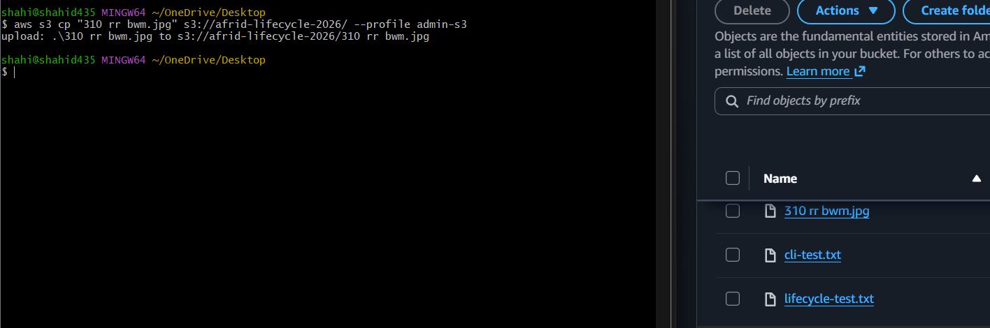

Important Command Explanation
aws s3 cp SOURCE DESTINATION --profile PROFILE-NAME
Example:
aws s3 cp cli-test.txt s3://afrid-lifecycle-2026/ --profile admin-s3
- aws → AWS CLI command
- s3 → Amazon S3 service
- cp → Copy/upload operation
- cli-test.txt → Local source file
- s3://afrid-lifecycle-2026/ → Destination S3 bucket
- --profile admin-s3 → Uses credentials configured under the admin-s3 profile

Result
- Successfully configured AWS CLI credentials using the Admin IAM user.
- Created the admin-s3 AWS CLI profile.
- Successfully uploaded a text file to Amazon S3.
- Successfully uploaded an image file to Amazon S3.

- Write a Bash script to create an S3 bucket.

Objective
- To automate the creation of an Amazon S3 bucket using a Bash script and AWS CLI.

Components Used
- Bash: A command-line scripting language used to automate tasks.
- AWS CLI: Used to interact with AWS services from the command line.
- IAM User Credentials: Used by the AWS CLI to authenticate with AWS.
- AWS CLI Profile:
admin-s3
- Amazon S3: AWS object storage service.
- S3 Bucket: The resource created by the script.
afrid-bash-s3-2026

Architecture
Bash Script
create-s3-bucket.sh
│
▼
AWS CLI
│
│ Uses admin-s3 profile
▼
AWS IAM Authentication
│
▼
Amazon S3
│
▼
afrid-bash-s3-2026

Bash Script
Created the script:
create-s3-bucket.sh
Script content:
#!/bin/bash

BUCKET_NAME="afrid-bash-s3-2026"
REGION="ap-southeast-1"

aws s3api create-bucket \
--bucket "$BUCKET_NAME" \
--region "$REGION" \
--create-bucket-configuration LocationConstraint="$REGION" \
--profile admin-s3

echo "S3 bucket creation command completed."

Implementation Steps
- Opened Git Bash.
- Worked in the directory:
/d/practice
- Created a Bash script:
vi create-s3-bucket.sh
- Added the S3 bucket creation script.
- Saved the script.
- Listed the files to verify the script:
ls
- Made the script executable:
chmod +x create-s3-bucket.sh
- Executed the script:
./create-s3-bucket.sh
- The script successfully created the bucket:
afrid-bash-s3-2026
- The bucket was created in:
Asia Pacific (Singapore)
ap-southeast-1

Verification
Listed all S3 buckets using:
aws s3 ls --profile admin-s3
Verified the configured AWS CLI profile Region:
aws configure get region --profile admin-s3
Output:
ap-southeast-1
Checked the actual location of a bucket using:
aws s3api get-bucket-location \
--bucket afrid-lifecycle-2026 \
--profile admin-s3
Output:
{
"LocationConstraint": "ap-southeast-1"
}
Also verified the newly created bucket in the AWS S3 Console.

Result
- Successfully created an S3 bucket using a Bash script.
- Automated the bucket creation process using Bash and AWS CLI.
- Created the bucket:

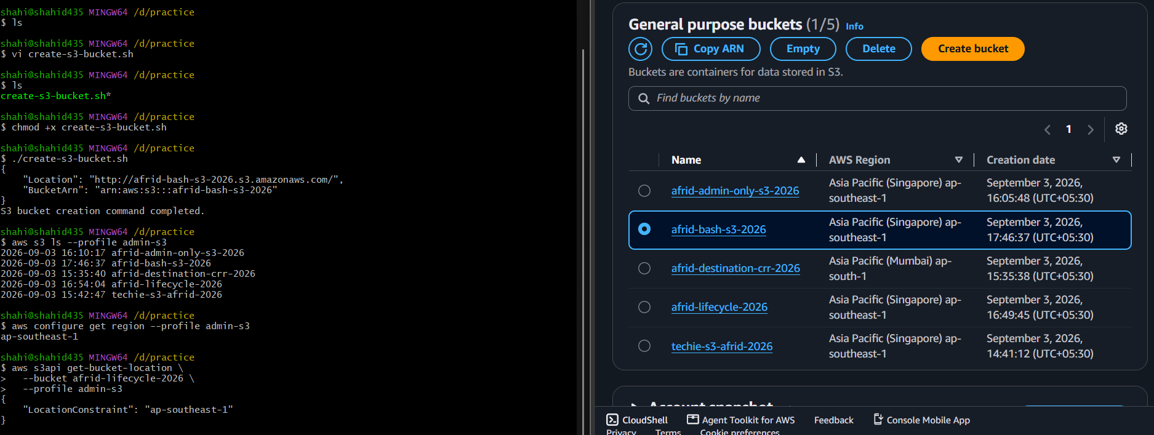
- Upload a 1 GB file to S3 using the CLI.

Objective
- To upload a large file (approximately 1 GB or more) from a local system to an Amazon S3 bucket using the AWS CLI.

Components Used
- AWS CLI: Command-line tool used to interact with AWS services.
- IAM User: Used to authenticate AWS CLI requests.
Admin
- AWS CLI Profile:
admin-s3
- Amazon S3: AWS object storage service.
- S3 Bucket: Destination bucket for the large file.
afrid-bash-s3-2026
- Large File: Local file uploaded to Amazon S3.
it 1 (1).mkv

Architecture
Local Computer
│
│ Large File
│ 1.26 GB
▼
AWS CLI
│
│ admin-s3 Profile
▼
IAM Authentication
│
▼
Amazon S3
│
▼
afrid-bash-s3-2026
│
▼
it 1 (1).mkv

Implementation Steps
- Identified an existing large file on the local system:
C:\Users\shahi\Videos\it 1 (1).mkv
- Checked the file size.
- The file size was:
1.26 GB
- Used the existing file instead of creating a new 1 GB file.
- Uploaded the file using AWS CLI.

Upload Command
aws s3 cp "/c/Users/shahi/Videos/it 1 (1).mkv" s3://afrid-bash-s3-2026/ --profile admin-s3

Command Explanation
aws s3 cp SOURCE DESTINATION --profile PROFILE-NAME

aws
Invokes the AWS CLI.

s3
Specifies the Amazon S3 service.

cp
Copies the local file to the S3 bucket.

Source
"/c/Users/shahi/Videos/it 1 (1).mkv"
The path of the local file.
Quotes were used because the filename contains spaces and parentheses.

Destination
s3://afrid-bash-s3-2026/
The destination S3 bucket.

Profile
admin-s3
Uses the AWS credentials configured under the admin-s3 profile.

Verification
Verified the uploaded object using:
aws s3 ls s3://afrid-bash-s3-2026/ --profile admin-s3
Also verified the uploaded file from:
AWS Console → S3 → afrid-bash-s3-2026 → Objects

Important Points
- AWS CLI can upload large files directly to Amazon S3.
- A file larger than 1 GB is suitable for demonstrating a large file upload.
- The file used in this task was 1.26 GB.
- AWS CLI handles large S3 uploads and may use multipart upload mechanisms automatically depending on the CLI configuration and file size.
- The local file does not need to be created specifically for the task; an existing large file can be used.

Result
- Successfully uploaded a 1.26 GB .mkv file to Amazon S3 using AWS CLI.
- Successfully demonstrated large-file upload using:
AWS CLI → Amazon S3

